Paper Title

**Automated detection of arrhythmias using different intervals of tachycardia ECG segments with convolutional neural**

**network**

1. **Preprocessing: Filtering & Segmentation**

::baseline is removed with Daubechies wavelet

that CNN eliminates the need for pre-processing and separate feature extraction technique

We employed an eleven-layer convolutional neural network (CNN) to automatically classify the four classes of ECG signals

1. **Feature Extraction**

We employed an eleven-layer convolutional neural network (CNN) to automatically classify the four classes of ECG signals

1. **Classification & Classifier**

……

1. **Accuracy**

97.60% and 99.00%

1. **Two Leads or One Lead ? In case of two leads .. how classification of two leads is merged to have final decision ?**

The total number of ECG segments used for net A (two seconds) and net B (five seconds)

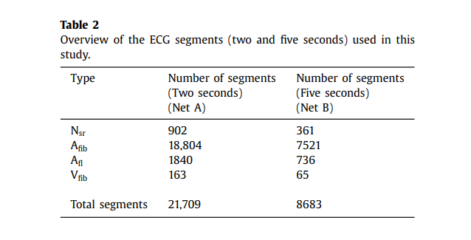

1. **Classes**

Classes (4) : (Nsr, Afib, Afl, and Vfib).

Vfib : Ventricular Fibrillation

Afib :(Atrial Fibrillation)

Afl (Atrial Flutter)

Nsr (Normal Sinus Rhythm)

**NOTES :**

. We propose to automatically classify the ECG signals using CNN without performing any noise filtering in our future work.